Risk Assessment – Mobile Rock Climbing Wall

Hazard |  | Who Is At Risk | Possible Effects/Harm | Likelihood  High/Med/Low | Evaluation & Control Measures | Revised Rating High/Med/Low | Are There Adequate Control Measures In Place
Falling from climbing wall and onto staff below | Participants/Staff |  | Risk of serious injury | High | Participants are belayed on a climbing rope which arrests fall. Participants to be fitted in a correctly sized harness, attached to the rope. All equipment to be inspected regularly and reviewed annually. Supervised by trained  Quads N Castles Staff | Medium | Yes. Staff to be trained in basic first aid to be used in the event of minor accidents and injuries.
Hitting the wall when descending | Participants |  | Risk of injury from hitting the climbing wall or other climbers | Medium | Participants are belayed on a climbing rope which arrests fall. Participants to be told how to make a controlled descent. | Medium | Yes
Failure of equipment | Participants |  | Risk of injury from failure of rope, belay or harness | Medium | All equipment to be inspected regularly and reviewed annually | Low | Yes
Falling objects | Staff, Participants and the public |  | Risk of injury from loose items falling from participants pockets or loose shoes/ clothing. | Low | Participants to empty pockets before using the wall and ensure shoes are properly fitted and secure. Barrier to be set up around the wall to protect the spectators. | Low | Yes
Inappropriate behavior | Staff, Participants and the public |  | Inappropriate behavior on the wall could result in injury or unsafe conditions | Medium | Participants to be supervised by Quads N Castles staff. Any persons behaving inappropriately are to be asked to vacate the wall. | Low | Yes
Fear of heights | Participants |  | Participant may become “frozen” on the wall or could experience an anxiety attack | 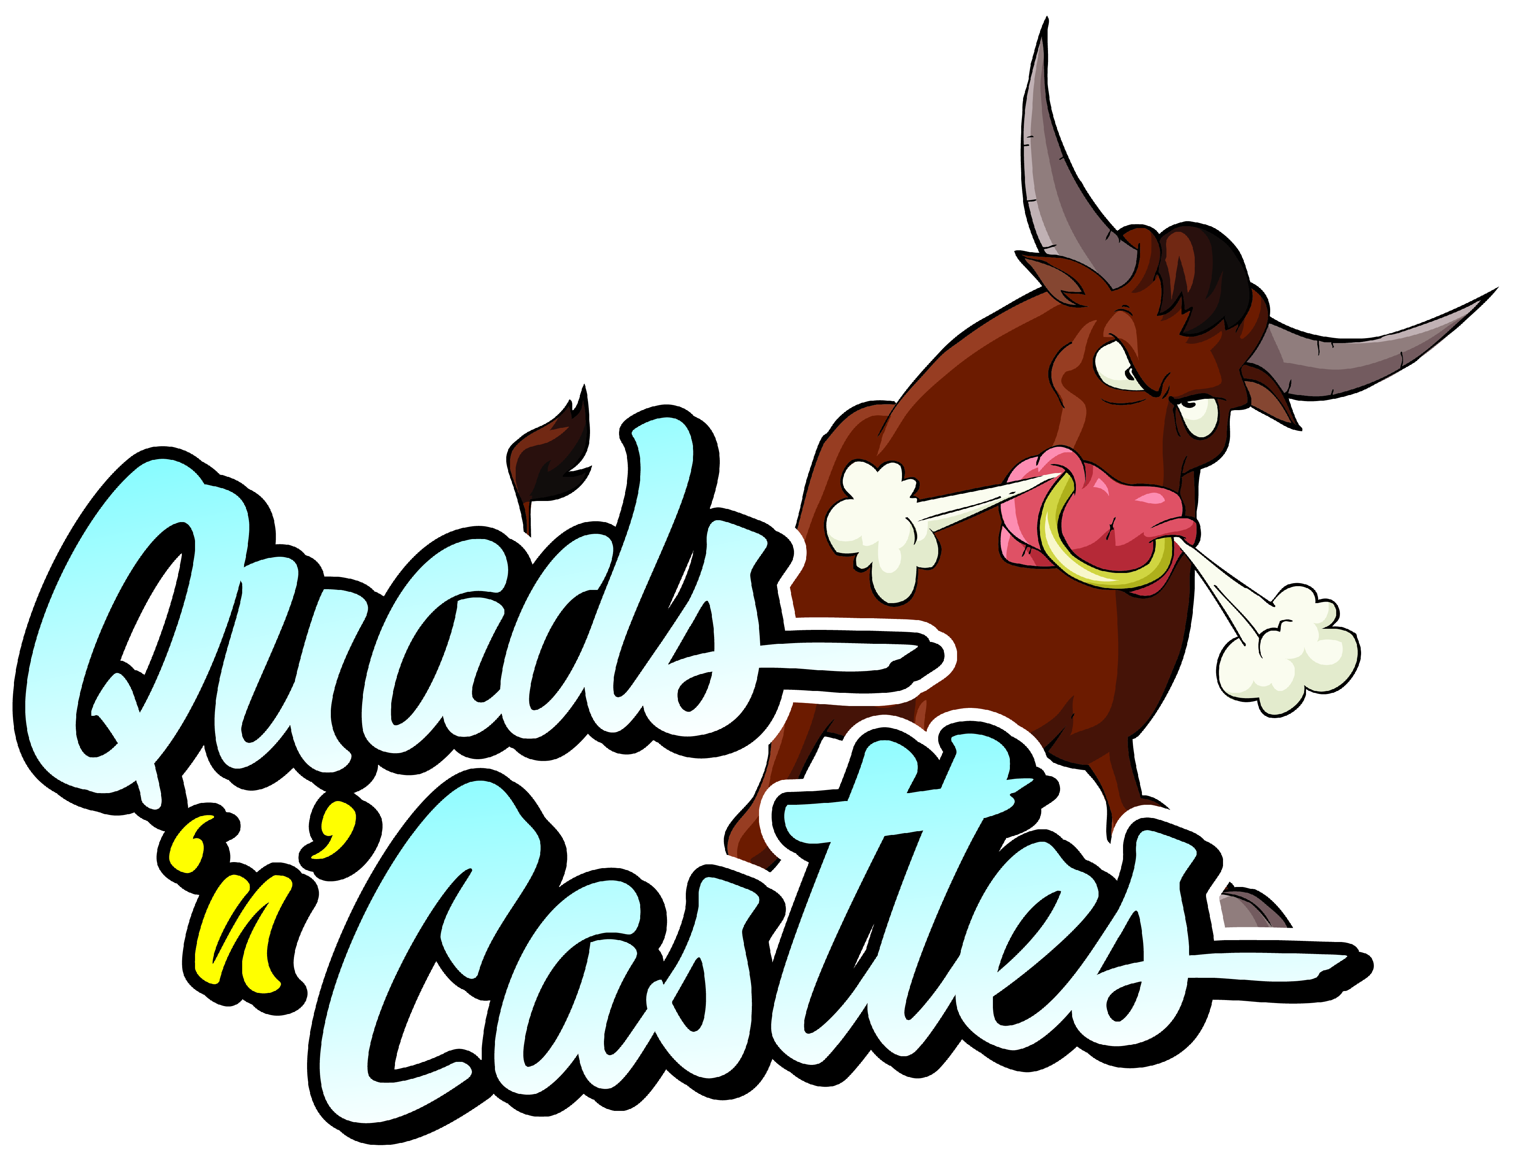  Medium | Participants to be reassured on how to make a controlled descent. Staff only to manually assist participants if fully trained and harnessed. | Low | Yes
Adverse weather conditions | Staff, Participants and the public |  | Danger of wall collapsing or being blown in the wind. Risk of slipping or falling in wet conditions | Medium | Wall should not be used in adverse weather conditions. Weather forecast to be checked before assembly of the wall. | Low | Yes

Risk rating
High For example:
• fatality possible to one or more individuals however infrequent
• major injury to few individuals occurring frequently
• likelihood of long term muscular-skeletal problems affecting significant numbers of staff Immediate action required
Medium For example:
• major injury to one/few individuals occurring infrequently
• likelihood of long term muscular-skeletal problems affecting some staff. Requires attention as soon as possible
Low For example:
• minor injury occurring infrequently to few staff. Not a priority, may need attention if not as low as reasonably practicable.

