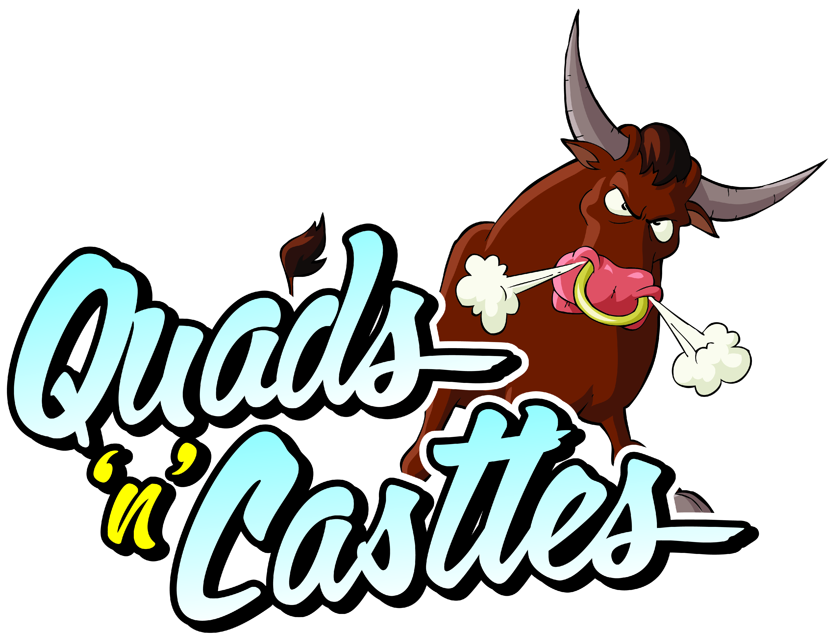**Risk Assessment – Human Whack A Mole**

|  |  |  |  |  |  |  |
| --- | --- | --- | --- | --- | --- | --- |
| **Hazard Area** | **Risk** | **Existing Controls** | **Likelihood**  **1 - 5** | **Severity**  **1 - 5** | **Risk Score**  **L x S** | **Further Action to take** |
| Human  Whack A Mole | Over enthusiastic participants | Responsible person supervising at all times. Rocking from side to side is NOT PERMITTED UNDER ANY CIRCUMSTANCES. | 2 | 1 | 1 | In the event of large numbers of participants trained operators will be supplied with the inflatable to aid with large numbers. |
| Human  Whack A Mole | Overloading or Tipping over. | No user weighing over 90kor 19 stone is permitted to use the equipment at any time. | 1 | 5 | 5 | None |
| Human  Whack A Mole | Larger participants colliding with smaller participants  Problem players | Responsible person supervising at all times. | 1 | 1 | 1 | Participants put into groups of similar size. |
| Human  Whack A Mole | Larger participants colliding with smaller participants | Responsible person supervising at all times. | 1 | 1 | 1 | Participants put into groups of similar size. |
| Human  Whack A Mole | Adverse weather conditions | The item will be switched off in heavy rain and is not permitted to run in strong winds as both these conditions can be deemed a health and safety risk. | Depends on weather | Depends on weather | Depends on weather | None |
| Human  Whack A Mole | Danger of injury from hard surfaces. | The inflatable must never be mounted unless the inflatable bed is fully inflated whether the inflatable is in operation or not as this can lead to serious injury. | 1 | 4 | 4 | None |
| Human  Whack A Mole | Injury through lack of supervision. | A fully trained operator must be present with he bull at all times, in the event that the operator is not in view Do Not enter the any circumstances. | 1 | 5 | 5 | None |
| Human  Whack A Mole | Tripping over anchorage points, spare equipment, electrical cables | Anchor points used as per manufacturers instructions and spare equipment erected safely or stowed away. Where possible electrical cable does not cross any public pathway. | 1 | 1 | 1 | In the event of large numbers of participants attending or large events, additional safety fencing is erected, electrical cables will be covered |
| Human  Whack A Mole | Injury through incorrect positioning. | Do not move or try to reposition the inflatable under any circumstances and ensure that the anchors are in place at all times. | 1 | 2 | 2 | None |
| Human  Whack A Mole | Petrol Blower, Generator Risk of fire | Blowers/generators filled with fuel before delivery, units are fire retardant. | 3 | 1 | 1 | All spare fuel is stored in suitable marked container, and in a safe location, units switched off during re fuelling, |
| Human  Whack A Mole | Choking | No food drinks or chewing gum to be allowed on or near the Inflatable. | 1 | 4 | 4 | None |
| Human  Whack A Mole | Injury through 3rd party items | All shoes, glasses, jewellery, badges MUST be removed before using this Inflatable. | 1 | 5 | 5 | None |
| Human  Whack A Mole | Danger of fire. | No smoking or barbecues near the Inflatable at any time. | 1 | 5 | 5 | None |
| Human  Whack A Mole | Danger of falling from height. | Climbing, hanging or sitting on walls is DANGEROUS and must not be allowed at any time, All our beds have low walls for supervision purposes, this rule is exceptionally important when the inflatable is erected on hard surfaces. | 1 | 3 | 3 | None |
| Human  Whack A Mole | Injury through 3rd party & Spectators. | Always ensure that the area surrounding the Inflatable is not overcrowded. | 2 | 3 | 6 | None |
| Human  Whack A Mole | Emergency | In the event that someone is seriously injured, DO NOT move the individual, leave the inflatable switched on and dial 999 immediately. | N/A | N/A | N/A | None |
| Human  Whack A Mole | Injury through Rope or netting | Rope or netting should be supervised to ensure participants do not become tangled. Supervisor should be provided at all time. | 1 | 2 | 2 | None |
| Human  Whack A Mole | Injury through lack of inflatable pressure or suffocation. | Do not allow anyone to be on the Inflatable during inflation or deflation as this can be EXTREMELY DANGEROUS. | 1 | 2 | 2 | None |
| Human  Whack A Mole | Injury through insecure anchorage. | Never use this unit without proper anchorage in place, It may be blown over in certain wind conditions, If the inflatable unit is not anchored correctly please ensure you tell the erection team before they leave as we keep a tight schedule and may not be able to return immediately. | 1 | 5 | 5 | None |

L=Likelihood S=Severity L*S= Risk 1=Low 5=High Risk is worked out using numbers 1 - 5. The likelihood is given a number and this is multiplied by the number given to the severity of the risk. The result = the risk factor. This generic risk assessment is brief and we have our own individual assessments for each individual risk, 25 being the worst possible outcome, any item reaching 25 would give serious cause for concern & we would not be able to erect the unit. It is recommended that clients undertake their own risk assessment to suit their requirements.